KEEP YOUR RHINO TOOL RUNNING SMOOTHLY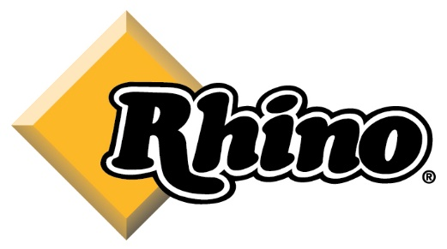

EACH USE:
Check Engine Oil Level
Check Air Cleaner
Check Crankcase Lubrication
Check Engine & Post Driver Fasteners

FIRST MONTH OR 10 HOURS:

Change Engine Oil

EVERY 3 MONTHS OR 25 HOURS:

Clean Air Cleaner – of more often if dusty

EVERY 6 MONTHS OR 50 HOURS:

Change Engine Oil

EVERY 12 MONTH OR 100 HOURS:

Replace Air Cleaner
Remove & Service Piston, Hammer and Anvil – See Owners Manual for Instructions

